# Exercises: Abstraction

This document defines the exercises for ["Java Advanced" course @ Software University](https://softuni.bg/courses/java-advanced). Please submit your solutions (source code) of all below described problems in [Judge](https://judge.softuni.bg/Contests/776).

## Fill the Matrix

Filling a matrix in the regular way (**top to bottom** and **left to right**) is boring. Write two **methods** that **fill** a **matrix** of size **N x** N in **two** different **patterns.** Both patterns are described below:

| **Pattern A** | **Pattern B** |
| --- | --- |
|  |  |

### Examples

|  |  |
| --- | --- |
| **Input** | **Output** |
| 3, A | 1 4 7  2 5 8  3 6 9 |
| 3, B | 1 6 7  2 5 8  3 4 9 |

### Hints

* Make a different method for each pattern
* Make a method for printing the matrix

## Matrix of Palindromes

Write a program to generate the following **matrix of palindromes** of **3** letters with **r** rows and **c** columns like the one in the examples below.

* **Rows** define the first and the last letter: row 0 🡪 ‘a’, row 1 🡪 ‘b’, row 2 🡪 ‘c’, …
* **Columns + rows** define the middle letter:
  + column 0, row 0 🡪 ‘a’, column 1, row 0 🡪 ‘b’, column 2, row 0 🡪 ‘c’, …
  + column 0, row 1 🡪 ‘b’, column 1, row 1 🡪 ‘c’, column 2, row 1 🡪 ‘d’, …

### Input

* The numbers r and c stay at the first line at the input.
* r and c are integers in the range [1…26].
* r + c ≤ 27

### Examples

|  |  |
| --- | --- |
| **Input** | **Output** |
| 4 6 | aaa aba aca ada aea afa  bbb bcb bdb beb bfb bgb  ccc cdc cec cfc cgc chc  ddd ded dfd dgd dhd did |
| 3 2 | aaa aba  bbb bcb  ccc cdc |

### Hints

* Use two nested loops to generate the matrix.
* Print the matrix row by row in a loop.
* Don’t forget to pack everything in methods.

## Diagonal Difference

Write a program that finds the **difference between the sums of the square matrix diagonals** (absolute value).

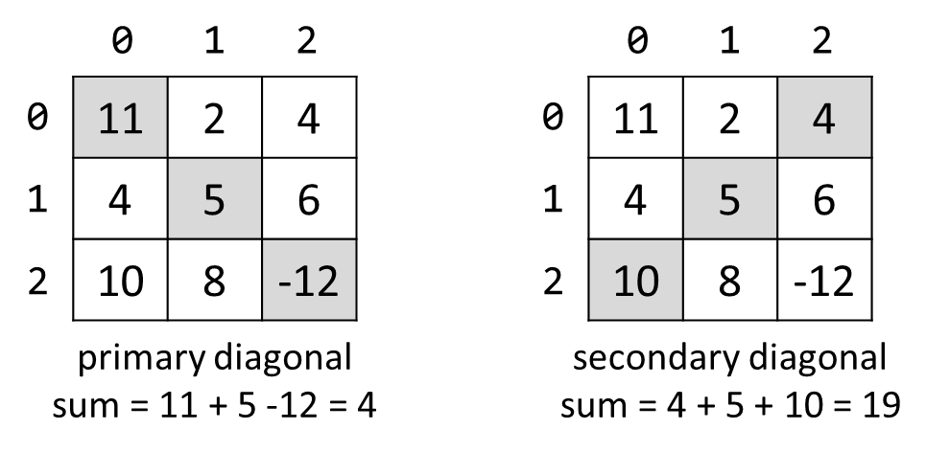

### Input

* The **first line** holds a number n – the size of matrix.
* The next n **lines** hold the **values for every row** – n numbers separated by a space.

### Examples

|  |  |  |
| --- | --- | --- |
| **Input** | **Output** | **Comments** |
| 3  11 2 4  4 5 6  10 8 -12 | 15 | **Primary diagonal:** sum = 11 + 5 + (-12) = 4  **Secondary diagonal:** sum = 4 + 5 + 10 = 19  **Difference:** |4 - 19| = 15 |

### Hints

* Use a **single** loop i = [1 … n] to sum the diagonals.
* The **primary diagonal** holds all cells {row, col} where row == col == i.
* The **secondary diagonal** holds all cells {row, col} where row == i and col == n-1-i.

## 2x2 Squares in Matrix

Find the count of **2 x 2 squares of equal chars** in a matrix.

### Input

* The matrix size is given at the first row (**rows** and **columns**).
* Matrix characters come at the next **rows** lines (space separated).

### Examples

|  |  |  |
| --- | --- | --- |
| **Input** | **Output** | **Comments** |
| 3 4  A B B D  E B B B  I J B B | 2 | Two 2 x 2 squares of equal cells:  A **B B** D A B B D  E **B B** B E B **B B**  I J B B I J **B B** |
| 2 2  a b  c d | 0 | No 2 x 2 squares of equal cells exist. |

### Hints

* Check all possible 2 x 2 squares for equal elements.
* Make sure your program wouldn’t throw an **IndexOutOfBoundsException()**

## Maximal Sum

Write a program that reads a rectangular integer matrix of size **N x M** and finds in it the square **3 x 3** that **has maximal sum of its elements**.

### Input

* On the first line, you will receive the rows **N** and columns **M**.
* On the next **N lines** you will receive **each row with its elements**.

Print the **elements** of the 3 x 3 square as a matrix, along with their **sum**. See the format of the output below:

### Examples

|  |  |  |
| --- | --- | --- |
| **Input** | **Output** | **Comments** |
| 4 5  1 5 5 2 4  2 1 4 14 3  3 7 11 2 8  4 8 12 16 4 | Sum = 75  1 4 14  7 11 2  8 12 16 |  |

## Sequence in Matrix

You are given a matrix of strings of size**N x M**. Sequences in the matrix are defined as sets of several neighbour elements, located on the same **diagonal, line or column** . Write a program that finds the longest sequence of equal strings in the matrix.

If there are **two sequences with the same length**, **print the one that you found last (Check the diagonals first, then the lines and last the columns)**

### Input

* On the first line, you will receive the rows **N** and columns **M**.
* On the next **N lines** you will receive **each row with its elements**.

### Examples

| **Input** | **Output** | **Comments** |
| --- | --- | --- |
| 3 4  ha fifi ho hi  fo ha hi xx  xxx ho ha xx | ha, ha, ha |  |
| 3 3  s qq s  pp pp s  pp qq s | s, s, s |  |

## Collect the Coins

Working with multidimensional arrays can be (and should be) fun. Let's make a game out of it.

You receive the layout of a **board** from the console. Assume it will always have **4 rows** which you'll get as strings, each on a separate line. Each character in the strings will represent a **cell** on the board. Note that the strings may be of different lengths.

You are the player and start at the **top-left** corner (that would be position **[0, 0]** on the board). On the fifth line of input you'll receive a string with movement commands which tell you where to go next, it will contain only these four characters – '**>**' (move **right**), '**<**' (move **left**), '**^**' (move **up**) and '**v**' (move **down**).

You need to keep track of two types of events – collecting **coins** (represented by the symbol '**$**', of course) and hitting the **walls** of the board (when the player tries to move off the board to **invalid** coordinates). When all moves are over, **print the amount of money** collected and the **number of walls hit**.

### Examples

|  |  |  |
| --- | --- | --- |
| **Input** | **Output** | **Comments** |
| Sj0u$hbc  $87yihc87  Ewg3444  $4$$  V>>^^>>>VVV<< | Coins = 2  Walls = 2 | Starting from (0, 0), move down (coin), twice right, up, up again (wall), three times right (coin on second move), twice down, down again (wall), twice to the left – game over (no more moves). Total of two coins collected and two walls hit in the process. |

### Hints

* Think about Exception Handling

## Matrix shuffling

Write a program which reads a string matrix from the console and performs certain operations with its elements. User input is provided in a similar way like in the problems above – first you read the **dimensions** and then the **data**.

Your program should then receive commands in format: "**swap row1 col1 row2c col2**" where row1, row2, col1, col2 are **coordinates** in the matrix. In order for a command to be valid, it should start with the "**swap**" keyword along with **four valid coordinates** (no more, no less). You should **swap the values** at the given coordinates (cell [row1, col1] with cell [row2, col2]) **and print the matrix at each step** (thus you'll be able to check if the operation was performed correctly).

If the **command is not valid** (doesn't contain the keyword "swap", has fewer or more coordinates entered or the given coordinates do not exist), print "**Invalid input!**" and move on to the next command. Your program should finish when the string "**END**" is entered.

### Examples

|  |  |
| --- | --- |
| **Input** | **Output** |
| 2 3  1 2 3  4 5 6  swap 0 0 1 1  swap 10 9 8 7  swap 0 1 1 0  END | 5 2 3  4 1 6  Invalid input!  5 4 3  2 1 6 |
| 1 2  Hello World  0 0 0 1  swap 0 0 0 1  swap 0 1 0 0  END | Invalid input!  World Hello  Hello World |

### Hints

* Think about Exception Handling

## * Terrorists Win!

On de_dust2 terrorists have planted a bomb (or possibly several of them)! Write a program that sets those bombs off!

A bomb is a string in the format **|...|**. When set off, the bomb destroys all characters inside. The bomb should also destroy **n** characters to the left and right of the bomb. **n** is determined by the **bomb** **power** (the **last digit of the ASCII sum** of the characters inside the bomb). Destroyed characters should be replaced by '**.**' (dot). For example, we are given the following text:

**prepare|yo|dong**

The bomb is **|yo|**. We get the bomb power by calculating the last digit of the sum: **y** (121) + **o** (111) = 23**2**. The bomb explodes and destroys itself and **2** characters to the left and **2** characters to the right. The result is:

**prepa........ng**

### Input

The input data should be read from the console. On the first and only input line you will receive the text.

The input data will always be valid and in the format described. There is no need to check it explicitly.

### Output

The destroyed text should be printed on the console.

### Constraints

* The lengthof the text will be in the range [1...1000].
* The bombs will hold a number of characters in the range [0…100].
* Bombs will not be nested (i.e. bomb inside another bomb).
* Bomb explosions will never overlap with other bombs.
* Time limit: 0.3 sec. Memory limit: 16 MB.

### Examples

|  |  |
| --- | --- |
| **Input** | **Output** |
| prepare|yo|dong | prepa........ng |
|  |  |
| **Input** | **Ouput** |
| de_dust2 |A| the best |BB|map! | de_d.............bes........p! |